**Project Structure**

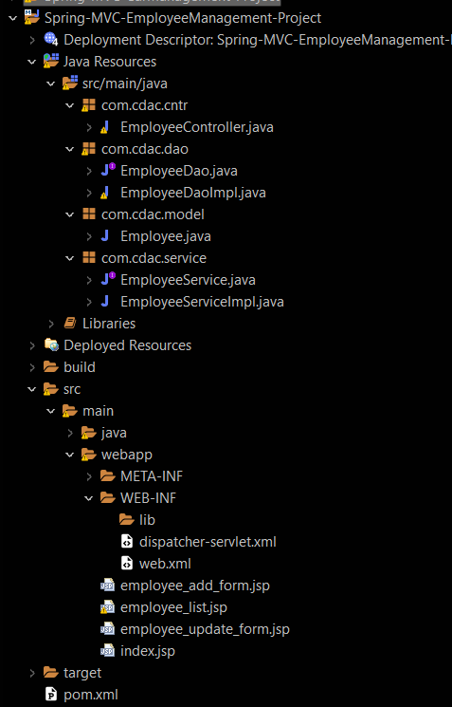

**Pom.xml**

<project xmlns="http://maven.apache.org/POM/4.0.0" xmlns:xsi="http://www.w3.org/2001/XMLSchema-instance" xsi:schemaLocation="http://maven.apache.org/POM/4.0.0 https://maven.apache.org/xsd/maven-4.0.0.xsd">

<modelVersion>4.0.0</modelVersion>

<groupId>com.cdac</groupId>

<artifactId>Spring-MVC-CRUD-Project</artifactId>

<version>0.0.1-SNAPSHOT</version>

<packaging>war</packaging>

<name>Spring-MVC-CRUD-Project</name>

<description>Spring Project</description>

<build>

<plugins>

<plugin>

<artifactId>maven-compiler-plugin</artifactId>

<version>3.8.1</version>

<configuration>

<release>11</release>

</configuration>

</plugin>

<plugin>

<artifactId>maven-war-plugin</artifactId>

<version>3.2.3</version>

</plugin>

</plugins>

</build>

<properties>

<spring.version>4.3.20.RELEASE</spring.version>

<aspectj.version>1.8.13</aspectj.version>

<mysql.connector.version>8.0.13</mysql.connector.version>

<hibernate.version>4.3.0.Final</hibernate.version>

</properties>

<dependencies>

<dependency>

<groupId>org.springframework</groupId>

<artifactId>spring-core</artifactId>

<version>${spring.version}</version>

</dependency>

<dependency>

<groupId>org.springframework</groupId>

<artifactId>spring-beans</artifactId>

<version>${spring.version}</version>

</dependency>

<dependency>

<groupId>org.springframework</groupId>

<artifactId>spring-context</artifactId>

<version>${spring.version}</version>

</dependency>

<dependency>

<groupId>org.springframework</groupId>

<artifactId>spring-context-support</artifactId>

<version>${spring.version}</version>

</dependency>

<dependency>

<groupId>org.springframework</groupId>

<artifactId>spring-jdbc</artifactId>

<version>${spring.version}</version>

</dependency>

<dependency>

<groupId>org.springframework</groupId>

<artifactId>spring-orm</artifactId>

<version>${spring.version}</version>

</dependency>

<dependency>

<groupId>org.springframework</groupId>

<artifactId>spring-web</artifactId>

<version>${spring.version}</version>

</dependency>

<dependency>

<groupId>org.springframework</groupId>

<artifactId>spring-webmvc</artifactId>

<version>${spring.version}</version>

</dependency>

<dependency>

<groupId>org.springframework</groupId>

<artifactId>spring-aop</artifactId>

<version>${spring.version}</version>

</dependency>

<dependency>

<groupId>org.aspectj</groupId>

<artifactId>aspectjrt</artifactId>

<version>${aspectj.version}</version>

</dependency>

<dependency>

<groupId>org.aspectj</groupId>

<artifactId>aspectjweaver</artifactId>

<version>${aspectj.version}</version>

</dependency>

<dependency>

<groupId>mysql</groupId>

<artifactId>mysql-connector-java</artifactId>

<version>${mysql.connector.version}</version>

</dependency>

<dependency>

<groupId>org.hibernate</groupId>

<artifactId>hibernate-core</artifactId>

<version>${hibernate.version}</version>

</dependency>

<dependency>

<groupId>org.hibernate</groupId>

<artifactId>hibernate-entitymanager</artifactId>

<version>${hibernate.version}</version>

</dependency>

<dependency>

<groupId>org.hibernate</groupId>

<artifactId>hibernate-ehcache</artifactId>

<version>${hibernate.version}</version>

</dependency>

<dependency>

<groupId>commons-fileupload</groupId>

<artifactId>commons-fileupload</artifactId>

<version>1.4</version>

</dependency>

<dependency>

<groupId>org.apache.tomcat</groupId>

<artifactId>tomcat-annotations-api</artifactId>

<version>9.0.62</version>

</dependency>

<dependency>

<groupId>org.apache.tomcat</groupId>

<artifactId>tomcat-catalina-ant</artifactId>

<version>9.0.62</version>

</dependency>

<dependency>

<groupId>org.apache.tomcat</groupId>

<artifactId>tomcat-catalina-ha</artifactId>

<version>9.0.62</version>

</dependency>

<dependency>

<groupId>org.apache.tomcat</groupId>

<artifactId>tomcat-ssi</artifactId>

<version>9.0.62</version>

</dependency>

<dependency>

<groupId>org.apache.tomcat</groupId>

<artifactId>tomcat-storeconfig</artifactId>

<version>9.0.62</version>

</dependency>

<dependency>

<groupId>org.apache.tomcat</groupId>

<artifactId>tomcat-tribes</artifactId>

<version>9.0.62</version>

</dependency>

<dependency>

<groupId>org.apache.tomcat</groupId>

<artifactId>tomcat-catalina</artifactId>

<version>9.0.62</version>

</dependency>

<dependency>

<groupId>org.eclipse.jdt</groupId>

<artifactId>ecj</artifactId>

<version>3.26.0</version>

</dependency>

<dependency>

<groupId>org.apache.tomcat</groupId>

<artifactId>tomcat-el-api</artifactId>

<version>9.0.62</version>

</dependency>

<dependency>

<groupId>org.apache.tomcat</groupId>

<artifactId>tomcat-jasper-el</artifactId>

<version>9.0.62</version>

</dependency>

<dependency>

<groupId>org.apache.tomcat</groupId>

<artifactId>tomcat-jasper</artifactId>

<version>9.0.62</version>

</dependency>

<dependency>

<groupId>org.apache.tomcat</groupId>

<artifactId>tomcat-jaspic-api</artifactId>

<version>9.0.62</version>

</dependency>

<dependency>

<groupId>org.apache.tomcat</groupId>

<artifactId>tomcat-jsp-api</artifactId>

<version>9.0.62</version>

</dependency>

<dependency>

<groupId>org.apache.tomcat</groupId>

<artifactId>tomcat-servlet-api</artifactId>

<version>9.0.62</version>

</dependency>

<dependency>

<groupId>org.apache.tomcat</groupId>

<artifactId>tomcat-api</artifactId>

<version>9.0.62</version>

</dependency>

<dependency>

<groupId>org.apache.tomcat</groupId>

<artifactId>tomcat-coyote</artifactId>

<version>9.0.62</version>

</dependency>

<dependency>

<groupId>org.apache.tomcat</groupId>

<artifactId>tomcat-dbcp</artifactId>

<version>9.0.62</version>

</dependency>

<dependency>

<groupId>org.apache.tomcat</groupId>

<artifactId>tomcat-i18n-cs</artifactId>

<version>9.0.62</version>

</dependency>

<dependency>

<groupId>org.apache.tomcat</groupId>

<artifactId>tomcat-i18n-de</artifactId>

<version>9.0.62</version>

</dependency>

<dependency>

<groupId>org.apache.tomcat</groupId>

<artifactId>tomcat-i18n-es</artifactId>

<version>9.0.62</version>

</dependency>

<dependency>

<groupId>org.apache.tomcat</groupId>

<artifactId>tomcat-i18n-fr</artifactId>

<version>9.0.62</version>

</dependency>

<dependency>

<groupId>org.apache.tomcat</groupId>

<artifactId>tomcat-i18n-ja</artifactId>

<version>9.0.62</version>

</dependency>

<dependency>

<groupId>org.apache.tomcat</groupId>

<artifactId>tomcat-i18n-ko</artifactId>

<version>9.0.62</version>

</dependency>

<dependency>

<groupId>org.apache.tomcat</groupId>

<artifactId>tomcat-i18n-pt-BR</artifactId>

<version>9.0.62</version>

</dependency>

<dependency>

<groupId>org.apache.tomcat</groupId>

<artifactId>tomcat-i18n-ru</artifactId>

<version>9.0.62</version>

</dependency>

<dependency>

<groupId>org.apache.tomcat</groupId>

<artifactId>tomcat-i18n-zh-CN</artifactId>

<version>9.0.62</version>

</dependency>

<dependency>

<groupId>org.apache.tomcat</groupId>

<artifactId>tomcat-jdbc</artifactId>

<version>9.0.62</version>

</dependency>

<dependency>

<groupId>org.apache.tomcat</groupId>

<artifactId>tomcat-jni</artifactId>

<version>9.0.62</version>

</dependency>

<dependency>

<groupId>org.apache.tomcat</groupId>

<artifactId>tomcat-util-scan</artifactId>

<version>9.0.62</version>

</dependency>

<dependency>

<groupId>org.apache.tomcat</groupId>

<artifactId>tomcat-util</artifactId>

<version>9.0.62</version>

</dependency>

<dependency>

<groupId>org.apache.tomcat</groupId>

<artifactId>tomcat-websocket</artifactId>

<version>9.0.62</version>

</dependency>

<dependency>

<groupId>org.apache.tomcat</groupId>

<artifactId>tomcat-websocket-api</artifactId>

<version>9.0.62</version>

</dependency>

</dependencies>

</project>

**Web.xml**

<?xml version="1.0" encoding="UTF-8"?>

<web-app xmlns:xsi="http://www.w3.org/2001/XMLSchema-instance"

xmlns="http://xmlns.jcp.org/xml/ns/javaee"

xsi:schemaLocation="http://xmlns.jcp.org/xml/ns/javaee http://xmlns.jcp.org/xml/ns/javaee/web-app_4_0.xsd"

id="WebApp_ID" version="4.0">

<display-name>Spring-MVC-CRUD-Project</display-name>

<welcome-file-list>

<welcome-file>index.html</welcome-file>

<welcome-file>index.jsp</welcome-file>

<welcome-file>index.htm</welcome-file>

<welcome-file>default.html</welcome-file>

<welcome-file>default.jsp</welcome-file>

<welcome-file>default.htm</welcome-file>

</welcome-file-list>

<servlet>

<servlet-name>dispatcher</servlet-name>

<servlet-class>org.springframework.web.servlet.DispatcherServlet</servlet-class>

</servlet>

<servlet-mapping>

<servlet-name>dispatcher</servlet-name>

<url-pattern>*.htm</url-pattern>

</servlet-mapping>

</web-app>

**Dispatcher-servlet.xml**

<?xml version="1.0" encoding="UTF-8"?>

<beans xmlns="http://www.springframework.org/schema/beans"

xmlns:xsi="http://www.w3.org/2001/XMLSchema-instance"

xmlns:aop="http://www.springframework.org/schema/aop"

xmlns:context="http://www.springframework.org/schema/context"

xmlns:jdbc="http://www.springframework.org/schema/jdbc"

xmlns:mvc="http://www.springframework.org/schema/mvc"

xmlns:p="http://www.springframework.org/schema/p"

xsi:schemaLocation="http://www.springframework.org/schema/beans http://www.springframework.org/schema/beans/spring-beans-4.3.xsd

http://www.springframework.org/schema/aop http://www.springframework.org/schema/aop/spring-aop-4.3.xsd

http://www.springframework.org/schema/context http://www.springframework.org/schema/context/spring-context-4.3.xsd

http://www.springframework.org/schema/jdbc http://www.springframework.org/schema/jdbc/spring-jdbc-4.3.xsd

http://www.springframework.org/schema/mvc http://www.springframework.org/schema/mvc/spring-mvc-4.3.xsd">

<context:component-scan base-package="com.cdac"></context:component-scan>

<bean id="viewResolver" class="org.springframework.web.servlet.view.InternalResourceViewResolver" >

<property name="prefix" value="/" ></property>

<property name="suffix" value=".jsp" ></property>

</bean>

<bean id="multipartResolver" class="org.springframework.web.multipart.commons.CommonsMultipartResolver" ></bean>

<bean id="dataSource" class="org.springframework.jdbc.datasource.DriverManagerDataSource" >

<property name="driverClassName" value="com.mysql.cj.jdbc.Driver" ></property>

<property name="url" value="jdbc:mysql://localhost:3306/pune?allowPublicKeyRetrieval=true" ></property>

<property name="username" value="root" ></property>

<property name="password" value="cdac" ></property>

</bean>

<bean id="sessionFactory" class="org.springframework.orm.hibernate4.LocalSessionFactoryBean" autowire="byType" >

<property name="hibernateProperties">

<props>

<prop key="hibernate.dialect">org.hibernate.dialect.MySQLDialect</prop>

<prop key="hibernate.show_sql">true</prop>

<prop key="hibernate.hbm2ddl.auto">update</prop>

</props>

</property>

<property name="annotatedClasses">

<list>

<value>com.cdac.model.Employee</value>

</list>

</property>

</bean>

<bean id="hibernateTemplate" class="org.springframework.orm.hibernate4.HibernateTemplate" autowire="byType" ></bean>

</beans>

**Employee.java**

package com.cdac.model;

import javax.persistence.Entity;

import javax.persistence.GeneratedValue;

import javax.persistence.GenerationType;

import javax.persistence.Id;

import javax.persistence.Table;

@Entity

@Table(name = "employee_table2")

public class Employee {

@Id

@GeneratedValue(strategy = GenerationType.IDENTITY)

private int id;

private String firstName;

private String lastName;

private double salary;

public Employee() {

}

public Employee(int id) {

super();

this.id = id;

}

public Employee(String firstName, String lastName, double salary) {

super();

this.firstName = firstName;

this.lastName = lastName;

this.salary = salary;

}

public Employee(int id, String firstName, String lastName, double salary) {

super();

this.id = id;

this.firstName = firstName;

this.lastName = lastName;

this.salary = salary;

}

public int getId() {

return id;

}

public void setId(int id) {

this.id = id;

}

public String getFirstName() {

return firstName;

}

public void setFirstName(String firstName) {

this.firstName = firstName;

}

public String getLastName() {

return lastName;

}

public void setLastName(String lastName) {

this.lastName = lastName;

}

public double getSalary() {

return salary;

}

public void setSalary(double salary) {

this.salary = salary;

}

@Override

public String toString() {

return "Employee [id=" + id + ", firstName=" + firstName + ", lastName=" + lastName + ", salary=" + salary

+ "]";

}

}

**EmployeeDao.java**

package com.cdac.dao;

import java.util.List;

import com.cdac.model.Employee;

public interface EmployeeDao {

public void save(Employee employee);

public void update(Employee employee);

public void deleteById(int id);

public Employee selectById(int id);

public List<Employee> selectAll();

}

**EmployeeDaoImpl.java**

package com.cdac.dao;

import java.util.List;

import org.hibernate.Query;

import org.hibernate.Transaction;

import org.springframework.beans.factory.annotation.Autowired;

import org.springframework.orm.hibernate4.HibernateTemplate;

import org.springframework.stereotype.Repository;

import com.cdac.model.Employee;

@Repository

public class EmployeeDaoImpl implements EmployeeDao {

@Autowired

private HibernateTemplate hibernateTemplate;

@Override

public void save(Employee employee) {

hibernateTemplate.execute(session -> {

Transaction t = session.beginTransaction();

session.save(employee);

t.commit();

session.flush();

session.close();

return null;

});

}

@Override

public void update(Employee employee) {

hibernateTemplate.execute(session -> {

Transaction t = session.beginTransaction();

session.update(employee);

t.commit();

session.flush();

session.close();

return null;

});

}

@Override

public void deleteById(int id) {

hibernateTemplate.execute(session -> {

Transaction t = session.beginTransaction();

session.delete(new Employee(id));

t.commit();

session.flush();

session.close();

return null;

});

}

@Override

public Employee selectById(int id) {

return hibernateTemplate.execute(session -> {

Transaction t = session.beginTransaction();

Employee employee = (Employee) session.get(Employee.class, id);

t.commit();

session.flush();

session.close();

return employee;

});

}

@Override

public List<Employee> selectAll() {

return hibernateTemplate.execute(session -> {

Transaction t = session.beginTransaction();

Query q = session.createQuery("from Employee");

List<Employee> lst = q.list();

t.commit();

session.flush();

session.close();

return lst;

});

}

}

**EmployeeService.java**

package com.cdac.service;

import java.util.List;

import com.cdac.model.Employee;

public interface EmployeeService {

public void add(Employee employee);

public void modify(Employee employee);

public void removeById(int id);

public Employee getById(int id);

public List<Employee> getAll();

}

**EmployeeServiceImpl.java**

package com.cdac.service;

import java.util.List;

import org.springframework.beans.factory.annotation.Autowired;

import org.springframework.stereotype.Service;

import com.cdac.dao.EmployeeDao;

import com.cdac.model.Employee;

@Service

public class EmployeeServiceImpl implements EmployeeService {

@Autowired

private EmployeeDao employeeDao;

@Override

public void add(Employee employee) {

employeeDao.save(employee);

}

@Override

public void modify(Employee employee) {

employeeDao.update(employee);

}

@Override

public void removeById(int id) {

employeeDao.deleteById(id);

}

@Override

public Employee getById(int id) {

return employeeDao.selectById(id);

}

@Override

public List<Employee> getAll() {

return employeeDao.selectAll();

}

}

**EmployeeController.java**

package com.cdac.cntr;

import java.util.List;

import org.springframework.beans.factory.annotation.Autowired;

import org.springframework.stereotype.Controller;

import org.springframework.ui.ModelMap;

import org.springframework.validation.BindingResult;

import org.springframework.web.bind.annotation.RequestMapping;

import org.springframework.web.bind.annotation.RequestMethod;

import org.springframework.web.bind.annotation.RequestParam;

import com.cdac.model.Employee;

import com.cdac.service.EmployeeService;

@Controller

public class EmployeeController {

@Autowired

private EmployeeService employeeService;

@RequestMapping(value = { "/employee_add_form.htm" })

public String employeeAddForm(ModelMap model) {

model.put("employee", new Employee());

return "employee_add_form";

}

@RequestMapping(value = { "/employee_add.htm" }, method = RequestMethod.POST)

public String employeeAdd(Employee employee, ModelMap model) {

employeeService.add(employee);

model.put("employee", employee);

return "employee_add_form";

}

@RequestMapping(value = { "/employee_list.htm" }, method = RequestMethod.GET)

public String employeeList(ModelMap model) {

List<Employee> lst = employeeService.getAll();

model.put("employees", lst);

return "employee_list";

}

@RequestMapping(value = { "/employee_delete.htm" }, method = RequestMethod.GET)

public String employeeDelete(@RequestParam(name = "id") int id, ModelMap model) {

employeeService.removeById(id);

List<Employee> lst = employeeService.getAll();

model.put("employees", lst);

return "employee_list";

}

@RequestMapping(value = { "/employee_update_form.htm" }, method = RequestMethod.GET)

public String employeeUpdateForm(@RequestParam(name = "id") int id, ModelMap model) {

Employee e = employeeService.getById(id);

model.put("employee", e);

return "employee_update_form";

}

@RequestMapping(value = { "/employee_update.htm" }, method = RequestMethod.POST)

public String employeeUpdate(Employee employee, ModelMap model) {

employeeService.modify(employee);

List<Employee> lst = employeeService.getAll();

model.put("employees", lst);

return "employee_list";

}

}

**index.jsp**

<%@ **page** language="java" contentType="text/html; charset=UTF-8"

pageEncoding="UTF-8"%>

<!DOCTYPE html>

<html>

<head>

<meta charset="UTF-8">

<title>Welcome Page</title>

</head>

<body>

<div align="center">

<h2>Employee Management System</h2>

<br> <a href="employee_add_form.htm"><b>Add Employee</b></a> <br> <br>

<a href="employee_list.htm"><b>View Employee List</b></a>

</div>

</body>

</html>

**Mobile_add_form.jsp**

<%@ **page** language="java" contentType="text/html; charset=UTF-8"

pageEncoding="UTF-8"%>

<%@ **taglib** uri="http://www.springframework.org/tags/form" prefix="spr"%>

<!DOCTYPE html>

<html>

<head>

<meta charset="UTF-8">

<title>Employee Add Form</title>

<script type="text/javascript">

**function** alertName() {

alert("Record added successfully");

}

</script>

</head>

<body>

<div align="center">

<h2>Employee add form</h2>

<br> <br>

<**spr:form** action="employee_add.htm" commandName="employee" method="post">

<div>

<label>First Name :</label>

<**spr:input** path="firstName" />

<span style="color: red"><**spr:errors** path="firstName"></**spr:errors**>

</span>

</div>

<br>

<div>

<label>Last Name :</label>

<**spr:input** path="lastName" />

<span style="color: red"><**spr:errors** path="lastName"></**spr:errors**>

</span>

</div>

<br>

<div>

<label>Salary :</label>

<**spr:input** path="salary" />

<span style="color: red"><**spr:errors** path="salary"></**spr:errors**>

</span>

</div>

<br>

<%-- <spr:button>Add</spr:button> --%>

<button onclick="myFunction()">Add</button>

<script>

**function** myFunction() {

alert("Record added successfully...");

}

</script>

</**spr:form**>

<br> <br> <a href="index.jsp">Back to Home page</a>

</div>

</body>

</html>

**Mobile_update_form.jsp**

<%@ **page** language="java" contentType="text/html; charset=UTF-8"

pageEncoding="UTF-8"%>

<%@ **taglib** uri="http://www.springframework.org/tags/form" prefix="spr"%>

<!DOCTYPE html>

<html>

<head>

<meta charset="UTF-8">

<title>Employee Update Form</title>

</head>

<body>

<div align="center">

<h2>Employee Update Form</h2>

<br>

<**spr:form** action="employee_update.htm" commandName="employee" method="post">

<**spr:hidden** path="id" />

<div>

<label>First Name :</label>

<**spr:input** path="firstName" />

</div>

<br>

<div>

<label>Last Name :</label>

<**spr:input** path="lastName" />

</div>

<br>

<div>

<label>Salary :</label>

<**spr:input** path="salary" />

</div>

<br>

<%-- <spr:button>Update</spr:button> --%>

<button onclick="myFunction1()">Update</button>

<script>

**function** myFunction1() {

alert("Record updated successfully...");

}

</script>

</**spr:form**>

<br> <br> <a href="index.jsp">Back to Home page</a>

</div>

</body>

</html>

**Mobile_list.jsp**

<%@**page** import="com.cdac.model.Employee"%>

<%@**page** import="java.util.List"%>

<%@ **page** language="java" contentType="text/html; charset=UTF-8"

pageEncoding="UTF-8"%>

<%

List<Employee> lst = (List<Employee>) request.getAttribute("employees");

%>

<!DOCTYPE html>

<html>

<head>

<meta charset="UTF-8">

<title>Employee List</title>

</head>

<body>

<div align="center">

<h1 align="center">Employee List</h1>

<table border="1" width="100%">

<thead>

<tr align="center">

<th>Id</th>

<th>First Name</th>

<th>Last Name</th>

<th>Salary</th>

<th>Delete</th>

<th>Update</th>

</tr>

</thead>

<tbody>

<%

for (Employee emp : lst) {

%>

<tr align="center">

<td><%=emp.getId()%></td>

<td><%=emp.getFirstName()%></td>

<td><%=emp.getLastName()%></td>

<td><%=emp.getSalary()%></td>

<td><a href="employee_delete.htm?id=<%=emp.getId()%>">Delete</a></td>

<td><a href="employee_update_form.htm?id=<%=emp.getId()%>">Update</a></td>

</tr>

<%

}

%>

</tbody>

</table>

<br> <br> <a href="index.jsp">Back to Home page</a>

</div>

</body>

</html>

**Web Browser And Database Screenshots**

**Homepage**

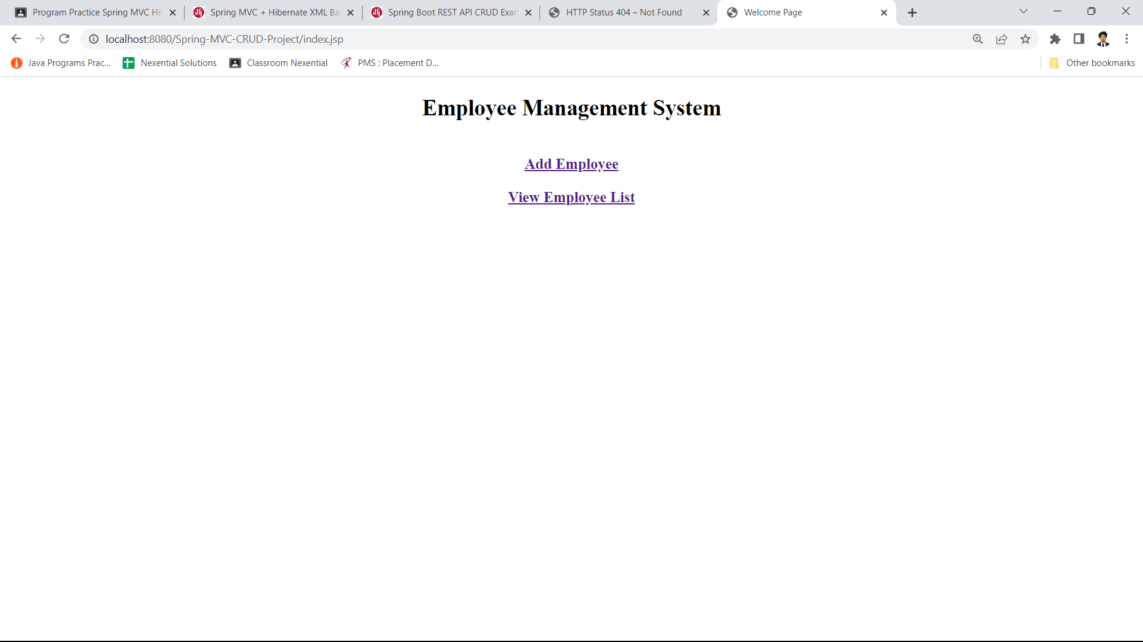

**Add**

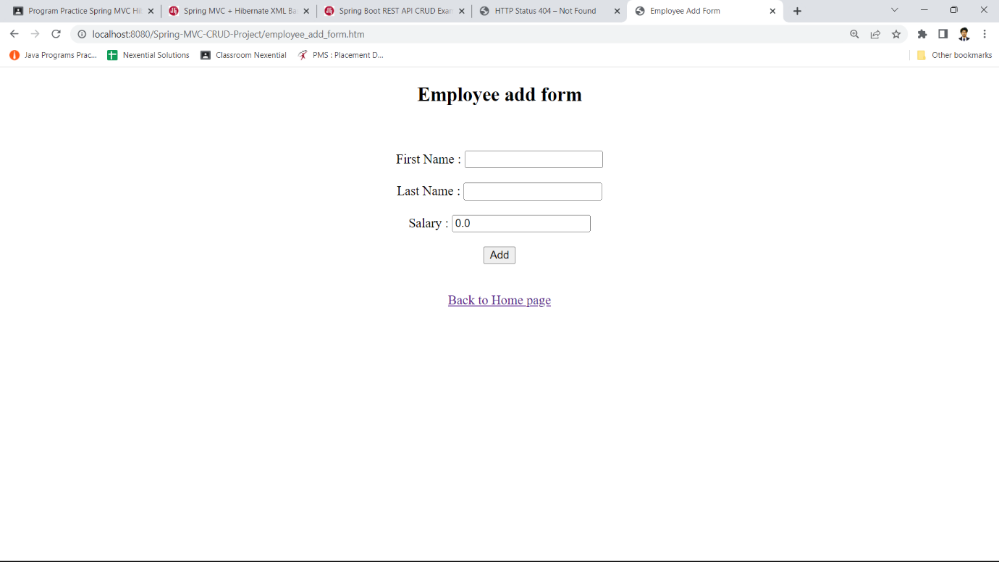

**Update**

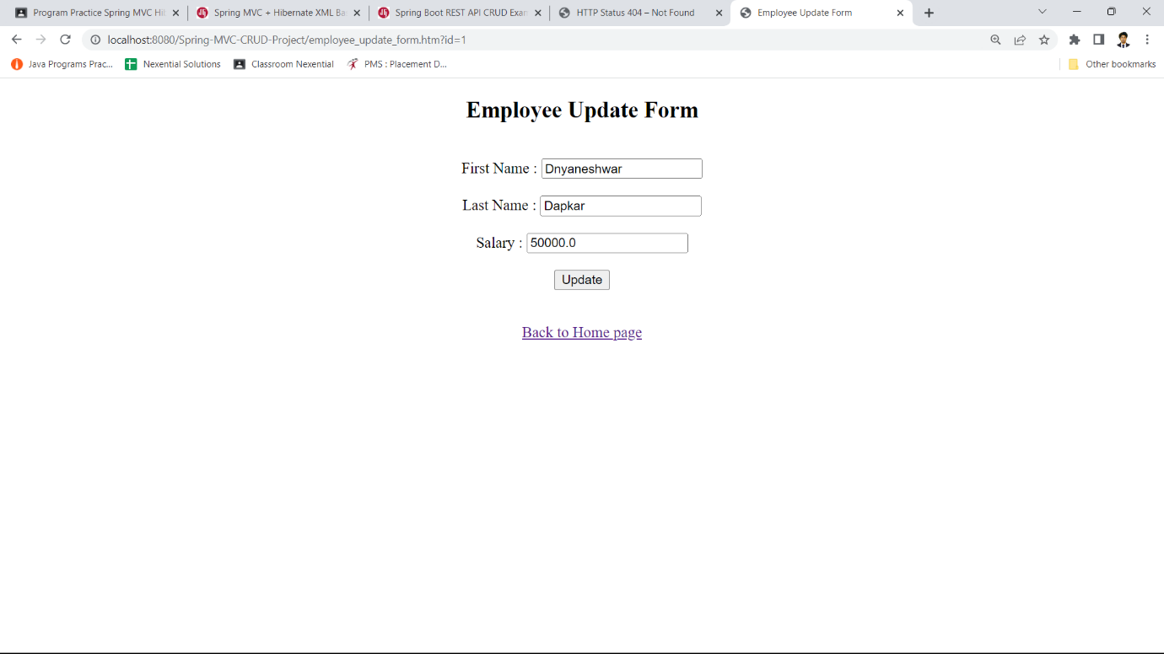

**Select All records**

